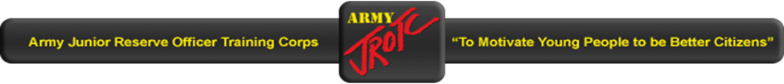
REQUIRED, AUTHORIZED AND PROHIBITED CADET CLOTHING & EQUIPMENT: (PACKING LIST) 2020 Camp Semaphore, Ft Gordon 1-5 June 2020
a. Cadets participating in Camp Semaphore are required to bring the following items:

Trousers, ACU |  |  | 3 pairs ARC JROTC
*Shirt, ACU |  |  | 3 each ARC JROTC
(utility with JROTC patch on left sleeve
and name tag or tape above right breast pocket)
Caps, OG 107 (utility) |  |  | 1 each ARC JROTC
Boots, combat (properly broken-in) |  |  | 1 pair ARC JROTC
Socks, cushion sole |  |  | 3 pairs ARC JROTC
Pistol Belt |  |  | 1 each ARC JROTC
Canteen |  |  | 1 each ARC JROTC
Canteen Cover |  |  | 1 each ARC JROTC
Duffel bag |  |  | 1 each ARC JROTC
Laundry bag |  |  | 1 each ARC JROTC
Poncho |  |  | 1 each ARC JROTC
Under garments (Bra mandatory for females) |  |  | 3 sets
*T-shirt, brown (Male & Female) |  |  | 3 each ARC JROTC
Bath Towels |  |  | 2 each
Wash Cloths |  |  | 4 each
Shower Shoes (flip-flops) |  |  | 1 pair
Soap, Personal/ Laundry |  |  | 1 bar / 1 small box or bag
Toilet Articles |  |  | As necessary
Health & Beauty Aids |  |  | As necessary
Padlock(s) |  |  | 1 each (recommend 2)
White athletic socks |  |  | 3 pairs
Athletic shoes |  |  | 1 pair
Athletic shorts (solid color) |  |  | 1 pair
Athletic shirt |  |  | 1 each
*White T-Shirt (Non-Swimmers) |  |  | 1 each
Lock with two keys |  |  | 1 key to company cadre
 | 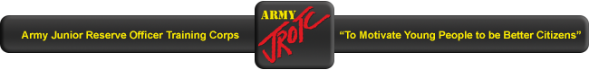
 | b. Additional items recommended that cadets bring to camp:
 |  | Civilian Clothing 2 changes
 |  | Swimsuit 1 each (One piece for females)
White T-shirt (For non-swimmers) 1 each
Bed Sheets/Pillow & Pillow case and Blanket
Sleeping Bag, optional

 | c. Optional items cadets may elect to bring to camp:
 |  | Small inexpensive radio/CD or Tape player with headphones
Small camera (Disposable Recommended) (Do not over pack.)
Spending Money to purchase snacks from store & PX!

 | d. Items cadets will not bring to camp:
 |  | Weapons (knives, guns, etc.)
 |  | Cell Phones, Beepers/Pagers
 |  | High value items
 |  | Large or expensive radios, CD/tape players, “Boom Boxes”
 |  | Class A or B uniforms
 |  | Cut-off trousers
 |  | Muscle shirts
 |  | Tank tops
 |  | Short-shorts
 |  | Halter tops, etc.
 |  | PROVOCATIVE CLOTHING WILL NOT BE ALLOWED

